Reflexology chart showing how acupressure points in the foot pertain to different parts of the body
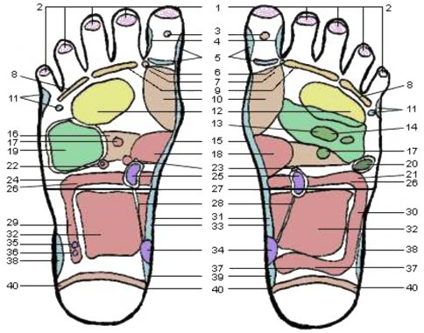
- Top of Head  - Sinuses  - Pituitary Gland  - Temporal Area  - Neck, Cervical  - Upper Lymph Area  - Parathyroid Gland  - Ears  - Eyes  - Thyroid Glands  - Shoulder  - Lungs and Bronchi  - Heart Area  - Heart | - Spine, Vertebra  - Pancreas  - Solar Plexus  - Stomach & Duodenum  - Liver  - Spleen  - Spleenic Fixture  - Gall Bladder  - Adrenal Glands  - Hepatic Flexure  - Kidneys  - Transverse Colon  - Waist  - Ureters | - Ascending Colon  - Descending Colon  - Lumbar  - Small Intestines  - Sacral  - Bladder  - Ileo-Caecal Valve  - Appendix  - Sigmoid Flexure  - Hip & Lower Back  - Coccyx  - Sciatic Area

